Task 1:
#include <stdio.h>
int main()
{
int marks,age;
printf("enter your age");
scanf(" %d",&age);
printf("\nenter marks");
scanf(" %d",&marks);
if(age>=18)
{
if(marks>=50)
{
printf("\nEligible for admission");
}
else
{
printf("\nnot enough marks");
}
}
else
{
printf("\n did not meet age requirement");
}
return 0;

}

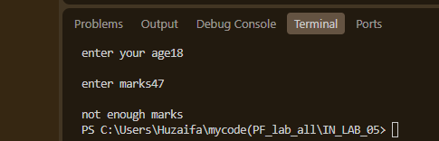

Task 2:
#include <stdio.h>
int main()
{
int ID,Test;
printf("\ndo you have a CNIC 1(yes) 0(no) ");
scanf(" %d",&ID);
printf("\ndid you pass the test 1(yes) 0(no) ");
scanf(" %d",&Test);
if(ID==1)
{
if(Test==1)
{
printf("\nLicense can be issued ");
}
else
{
printf("\ndid not pass test");
}
}
else
{
printf("\nno CNIC document ");
}

}

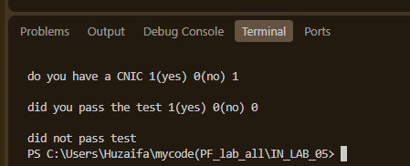

Task 4:
#include <stdio.h>
int main()
{
int marks;
printf("\nenter marks");
scanf(" %d",&marks);
(marks >= 50 ? printf("PASS") : printf("FAIL"));
return 0;

}

